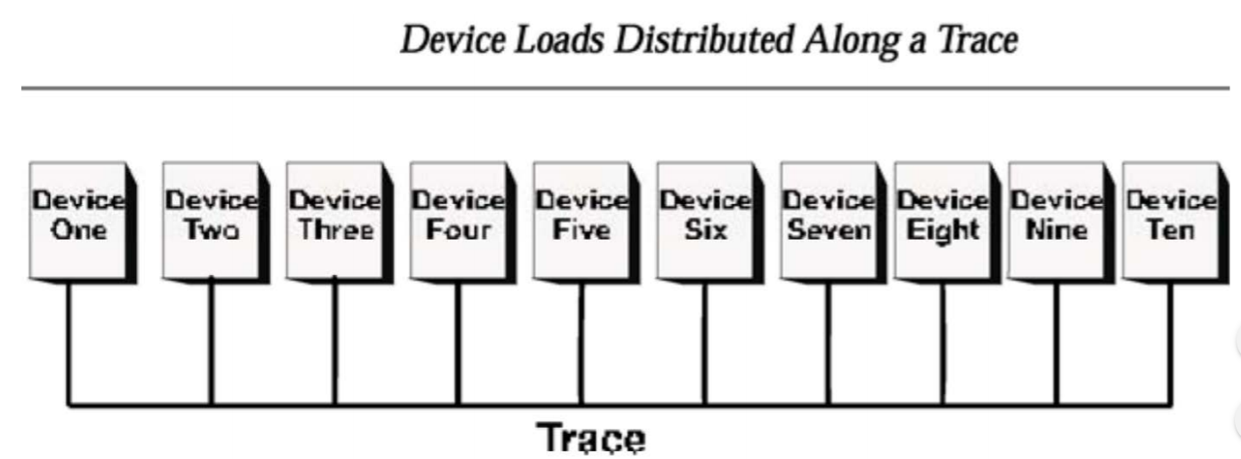

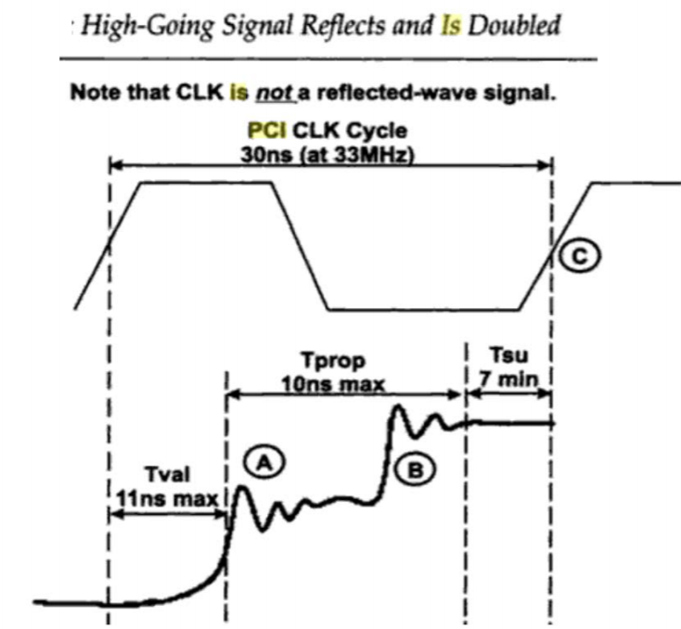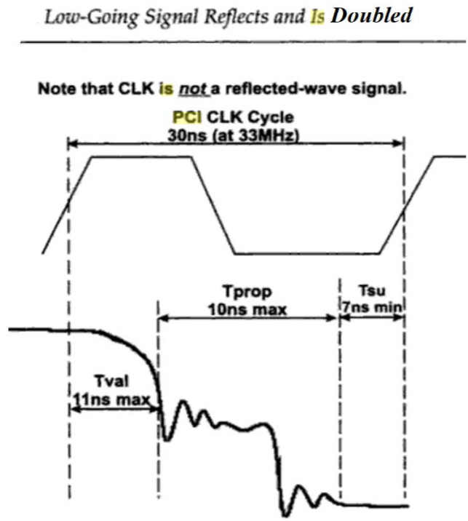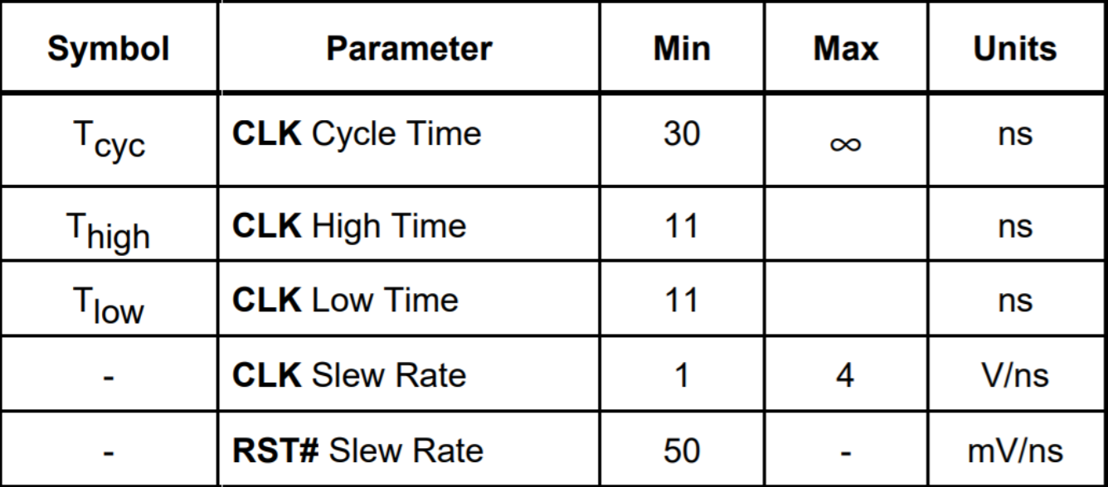

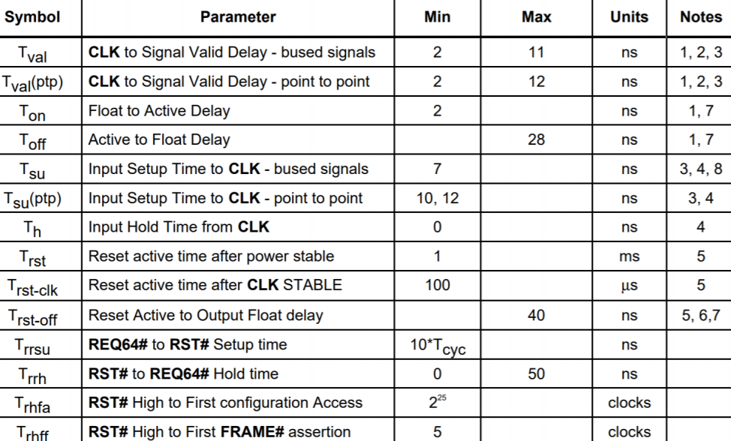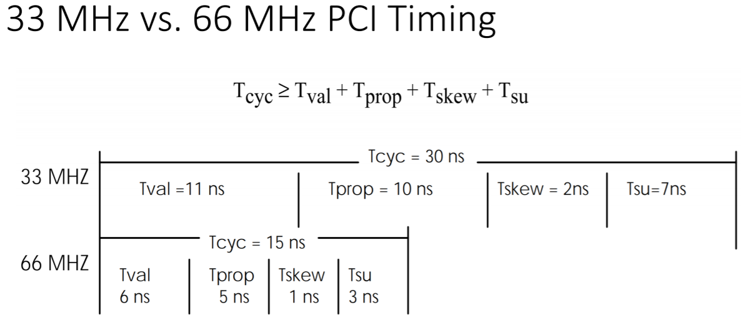

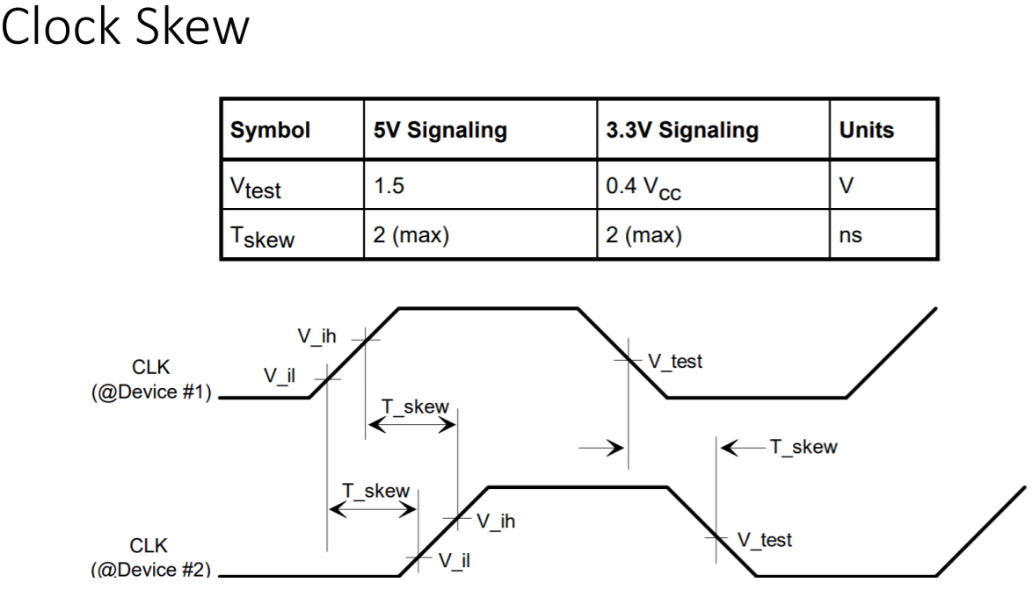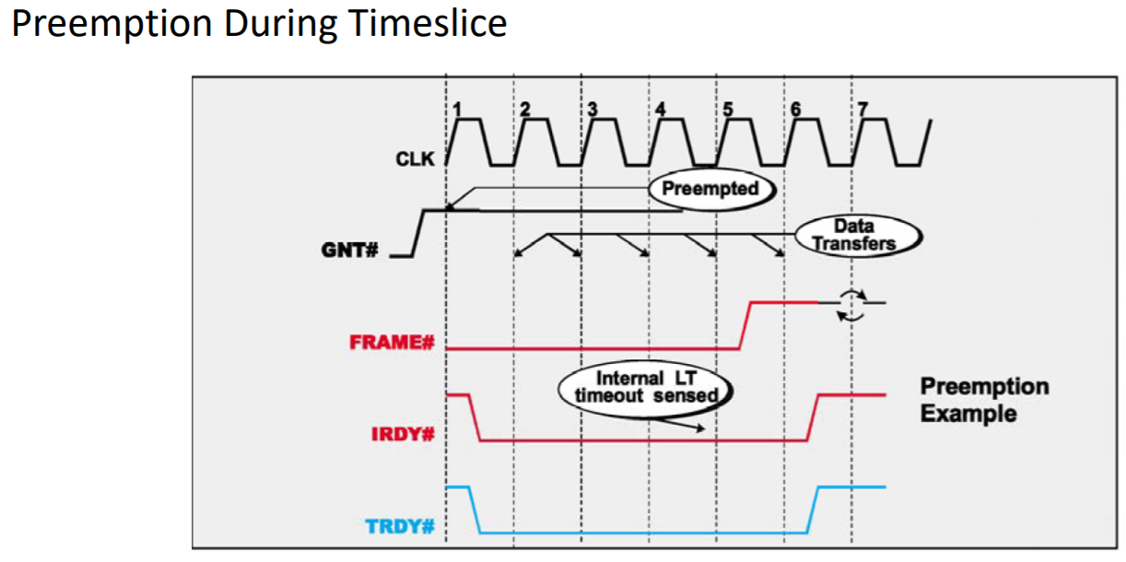

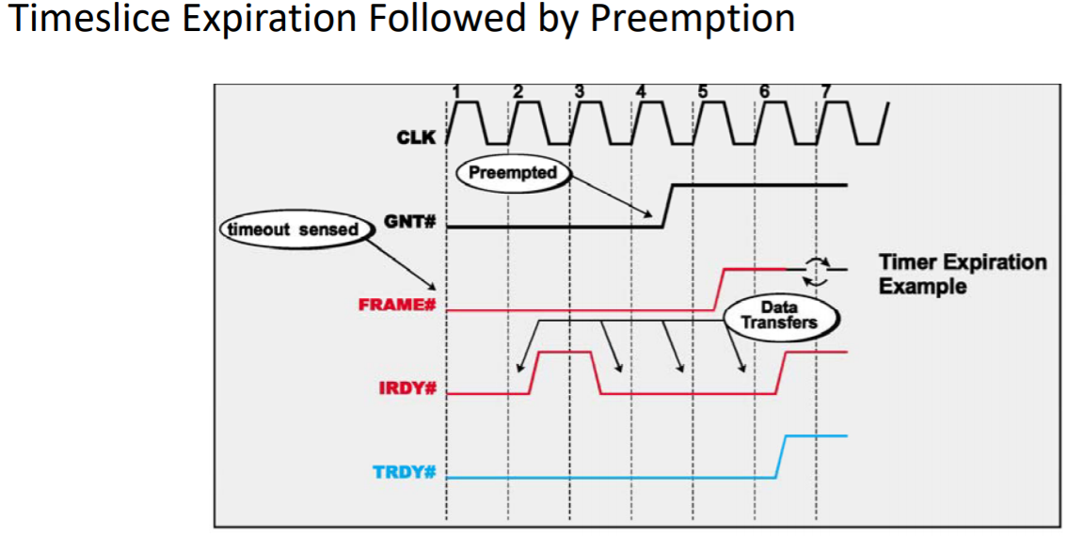

The initiator terminates a transaction for one of four reasons:

1. The transaction has completed normally.

2. The initiator has already used up its the slice and has been living on borrowed time and is then preempted by the arbiter (because one or more other bus masters are requesting the bus) before it completes its burst transfer. The initiator's Latency Timer expired some time ago and the arbiter has now removed the initiator's bus grant signal (GNT#). 3. The Initiator is preempted during its time slice and then uses up its allotted time slice before completing its overall transfer.

4. The initiator has aborted the transaction because no target has responded to the address. This is referred to as a Master Abort.

Master Abort: Target Doesn't Claim Transaction

Generally speaking, a Master Abort occurs when the transaction is not claimed by a target (DEVSEL# is not sampled asserted).  This could occur for several reasons:

Addressing Non‐Existent Device, Normal Response To Special Cycle Transaction (message broadcasting) , Configuration Transaction Unclaimed, No Target Will Claim Transaction Using Reserved Command